**CHAPTER 1**

**OVERVIEW OF THE ACCCEPTED SDLC MODEL**

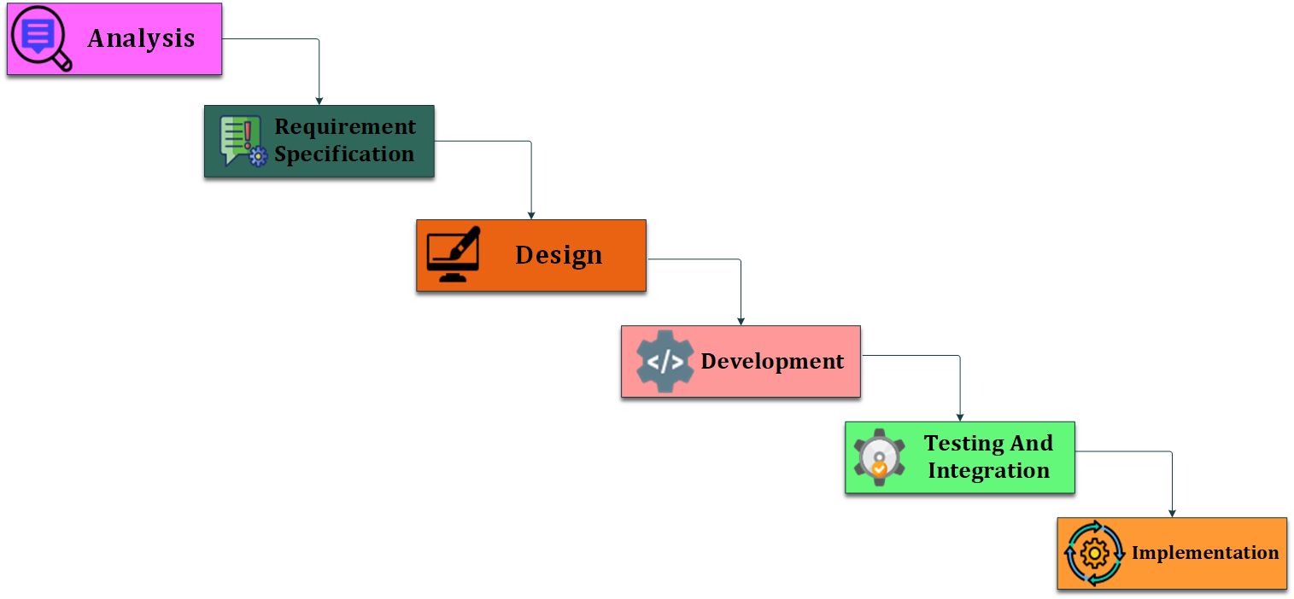

**𝐖𝐚𝐭𝐞𝐫𝐟𝐚𝐥𝐥 𝐌𝐨𝐝𝐞𝐥**

* 𝘞𝘦 𝘢𝘳𝘦 𝘶𝘴𝘪𝘯𝘨 𝘞𝘢𝘵𝘦𝘳 𝘧𝘢𝘭𝘭 𝘔𝘰𝘥𝘦𝘭 𝘣𝘦𝘤𝘢𝘶𝘴𝘦 𝘦𝘢𝘤𝘩 𝘱𝘩𝘢𝘴𝘦 𝘮𝘶𝘴𝘵 𝘣𝘦 𝘤𝘰𝘮𝘱𝘭𝘦𝘵𝘦𝘥 𝘣𝘦𝘧𝘰𝘳𝘦 𝘵𝘩𝘦 𝘯𝘦𝘹𝘵 𝘱𝘩𝘢𝘴𝘦 𝘤𝘢𝘯 𝘣𝘦𝘨𝘪𝘯 𝘢𝘯𝘥 𝘵𝘩𝘦 𝘧𝘭𝘰𝘸 𝘰𝘧 𝘸𝘢𝘵𝘦𝘳 𝘧𝘢𝘭𝘭 𝘮𝘰𝘥𝘦𝘭 𝘪𝘯 𝘢 𝘭𝘪𝘯𝘦𝘢𝘳 𝘴𝘦𝘲𝘶𝘦𝘯𝘵𝘪𝘢𝘭.
* 𝘱𝘩𝘢𝘴𝘦 𝘢𝘳𝘦 𝘱𝘳𝘰𝘤𝘦𝘴𝘴𝘦𝘥 𝘢𝘯𝘥 𝘢𝘵 𝘢 𝘵𝘪𝘮𝘦.
* 𝘤𝘢𝘯𝘯𝘰𝘵 𝘳𝘦𝘱𝘦𝘢𝘵 𝘱𝘳𝘦𝘷𝘪𝘰𝘶𝘴 𝘴𝘵𝘦𝘱
* 𝘐𝘵 𝘪𝘴 𝘵𝘦𝘳𝘮𝘦𝘥 𝘢𝘴 𝘸𝘢𝘵𝘦𝘳𝘧𝘢𝘭𝘭 𝘣𝘦𝘤𝘢𝘶𝘴𝘦 𝘵𝘩𝘦 𝘮𝘰𝘥𝘦𝘭 𝘥𝘦𝘷𝘦𝘭𝘰𝘱𝘴 𝘴𝘺𝘴𝘵𝘦𝘮𝘢𝘵𝘪𝘤𝘢𝘭𝘭𝘺 𝘧𝘳𝘰𝘮 𝘰𝘯𝘦 𝘱𝘩𝘢𝘴𝘦 𝘵𝘰 𝘢𝘯𝘰𝘵𝘩𝘦𝘳 𝘪𝘯 𝘢 𝘥𝘰𝘸𝘯𝘸𝘢𝘳𝘥 𝘧𝘢𝘴𝘩𝘪𝘰𝘯.

**CHAPTER 2**

**REQUIREMENT GATHERING AND ANALYSIS**

1. **Organization details**
   * **Name of organization:**
     + LIC
   * **Brief details of the organization:**
     + LIC provides many types of insurance policies to their customers according to their requirements. There are types of term insurance plans, life insurance plans, child plans, endowment plans, pension plans, etc. We have listed out a few top policies from different sectors. doloremque numquam quod.
     + It is almost 64 years since the company got established.
2. **Meetings**
   * **Meeting with a LIC agent:**
     + **Name of the LIC agent:**

Khushal Rajani

* + - **Requirements of the Vijay Mehta:**
      * Collecting Customer Information , Collecting policy records , Calculating own commission . Adding a new policy , and explaining all those policies to own customer etc…

1. **Type of project**
   * Web application.
2. **Method of collecting requirements**
   * Meetings / Interview.
   * Observing the data gathered.

**CHAPTER 3**

**SYSTEM REQUIREMENT SPECIFICATION**

* 1. **Introduction**
* LIC agent is a web application that allows agents to collect their customers information and provide information about policy. And calculate own commission.
  + 1. **Purpose**
  + The purpose of this software is collect agent’s customer information.
  + Collecting policy information.
  + Finding own commission.
    1. **Scope**
       - Agent can easily store client’s information in mobile and computer.
       - Agent can any time read client information.
       - Agent can find own commission very easily.
       - And agent can also store policy information and easily explain the policy information to his client.
    2. **Operating Environment**
       - Any computer device and mobile with browser can access our software.
    3. **User Classes**
       - **Admin**
         * Only admin is use our software. Admin can insert , Update , Delete of client data.
         * Only admin is store policy records.
         * Ex. Agent is admin. Agent’s store own client data and find own commission , agent can store policy information , agent can insert , update and delete data.
  1. **System Modules**
     + **Admin**
       - Administration have all rights to perform insert / update / delete data and store information.
       - Admin can store policy information.
       - Admin can find own commission.
  2. **Feasibility study**

A feasibility study is a preliminary investigation of a proposed system to decide whether the system can run smoothly with the organization.

* + 1. **Operational Feasibility:**

Operational feasibility is the measure of how well a proposed system solves the problems, and take advantage of the opportunities identified in the requirements analysis phase of the system development.

* + 1. **Technical Feasibility:**

Technical feasibility determines whether the work for the project can be done with existing equipment, software technology and available personal.

* + *Operating Environment*
  + *Windows : 7/8/10/11*
  + *Minimum RAM : 1GB*
  + *Storage : 10GB*
* **Hardware Interface Requirements**
  + - * 512+ MB of RAM
      * Multimedia keyboard and Mouse
      * 1.0+ GHz Processor
      * Monitor
* **Software Interface Requirements**
  + - * Operating System: Microsoft Windows 7 or Above
      * Front End Tools: PHP, HTML, Bootstrap
      * Back End Tools: MySQL
      * Browser specification: Google Chrome
    1. **Economic Feasibility:**
* Economic feasibility determines whether there are sufficient benefits in creating to make the cost acceptable, or is the cost of the system too high.
* So this signifies cost benefit analysis and savings on the behalf of the cost benefit analysis.
  + 1. **Communication Requirements**
    - How long will it take to get the technical expertise?
    - We may have the technology, but that doesn`t mean we have the skill required to properly apply that technology.
    1. **User Interface**
* In case the user is not registered. He/She can enter the details and create an account. Once the account is created user can ‘login’. If the username or password is incorrect then an error message appears.
  1. **Non-functional Requirements**
     1. **Performance Requirements**
* Overall System should be fast and error-free.
* It should have built-in error checking and correction facilities.
* The system should be able to handle large amounts of data.
  + 1. **Security Requirements**
* Users must Have Proper permission to perform tasks.

**CHAPTER - 4**

**SYSTEM ANALYSIS AND MODELING**

**4.1 Un-Normalization & Normalization**

* **Un-Normalization**

|  |  |  |  |  |  |
| --- | --- | --- | --- | --- | --- |
| Id | Name | Password | Mobile No: | Email - id | Client And policy |
| 1 | Darshan | 123 | 123456789 | pobaru@gmail.com | |  |  |  |  |  | | --- | --- | --- | --- | --- | | Client Name | Age | Address | Policy_name | Policy_detail | | Shyam | 20 | jamnagar | LIC's Cancer Cover | This is a fixed benefit health plan offering payouts for treatment of cancer. | |
| 2 | Rachchh | darshan | 123456789 | darshan@gmail.com | |  |  |  |  |  | | --- | --- | --- | --- | --- | | Client Name | Age | Address | Policy_name | Policy_detail | | Lakhan | 25 | surat | LIC's Cancer Cover | This is a fixed benefit health plan offering payouts for treatment of cancer. | |

* **Normalization**

1. **1st Normal Form :**
2. Table Name :- Register

Primary Key :- id ( Auto Increment )

|  |  |  |  |  |
| --- | --- | --- | --- | --- |
| Id(PK) | Name | Password | Mobile No: | Email - id |
| 1 | Darshan | 123 | 123456789 | pobaru@gmail.com |
| 2 | Rachchh | darshan | 123456789 | darshan@gmail.com |

1. Table Name :- Policy

|  |  |  |
| --- | --- | --- |
| id | Policy_name | Policy_detail |
| 1 | LIC's Cancer Cover | This is a fixed benefit health plan offering payouts for treatment of cancer. In case the customer is diagnosed with cancer, this plan will offer benefits irrespective of the costs incurred in the treatment. LIC Cancer Cover provides protection in case of Early Stage and Major Stage Cancer. |
| 2 | LIC's Jeevan Arogya | LIC's Jeevan Arogya is a unique non-participating non-linked plan which provides health insurance cover against certain specified health risks and provides you with timely support in case of medical emergencies and helps you and your family remain financially independent in difficult times. |

1. **2nd Normal Form :**

is organizing the columns

(attributes) and tables (relations) of a relational database to

reduce data redundancy and improve data integrity.

Here I define the second normalization

**1. Table Name:- Register**

|  |  |  |  |  |
| --- | --- | --- | --- | --- |
| Id (PK-AI) | Name | Password | Mobile No: | Email - id |
| 1 | Darshan | 123 | 123456789 | pobaru@gmail.com |
| 2 | Rachchh | darshan | 123456789 | darshan@gmail.com |

**2. Table Name : - Policy_details**

|  |  |  |  |
| --- | --- | --- | --- |
| Id(PK) | User_id (FK) | Policy_name | Policy_detail |
| 1 | 2 | Jivan Bima | LIC's Jeevan Arogya is a unique non-participating non-linked plan which… |
| 2 | 1 | Cancer cover | This is a fixed benefit health plan offering payouts for treatment of cancer… |

**4.2 Data Dictionary**

A data dictionary contains metadata i.e data about the database. The data dictionary is very important as it contains information such as what is in the database, who is allowed to access it, where is the database physically stored, etc. The users of the database normally don't interact with the data dictionary, it is only handled by the database administrators.

***Database Name: client***

## form_no_302

|  |  |  |  |  |
| --- | --- | --- | --- | --- |
| **Column** | **Type** | **Null** | **Default** | **Comments** |
| id (Primary) | int(100) | No |  |  |
| User_id | int(11) | No |  |  |
| Name | varchar(30) | No |  |  |
| Father_full_name | varchar(30) | No |  |  |
| Mother_full_name | varchar(30) | No |  |  |
| Wife_full_name | varchar(30) | No |  |  |
| Gender | varchar(10) | No |  |  |
| Merried | varchar(10) | No |  |  |
| Birth_date | int(10) | No |  |  |
| Age | int(100) | No |  |  |
| Proof_of_age_provided | varchar(20) | No |  |  |
| Birth_place | varchar(20) | No |  |  |
| Nationality | varchar(10) | No |  |  |
| Citizenship | varchar(20) | No |  |  |
| Correspondence_address | varchar(20) | No |  |  |
| House_no1 | varchar(20) | No |  |  |
| City | varchar(10) | No |  |  |
| District | varchar(15) | No |  |  |
| State | varchar(10) | No |  |  |
| Country | varchar(20) | No |  |  |
| Pin_code | int(10) | No |  |  |
| S_T_D | varchar(20) | No |  |  |
| Policy_name | varchar(15) | No |  |  |
| Address | varchar(50) | No |  |  |
| House_no2 | varchar(40) | No |  |  |
| City2 | varchar(20) | No |  |  |
| District2 | varchar(10) | No |  |  |
| State2 | varchar(10) | No |  |  |
| Country2 | varchar(15) | No |  |  |
| Pin_code2 | varchar(10) | No |  |  |
| S_T_D2 | int(10) | No |  |  |
| Name_address_of_heir | varchar(30) | No |  |  |
| Percentage_share | varchar(100) | No |  |  |
| Age2 | int(100) | No |  |  |
| Relationship_with_insured | varchar(50) | No |  |  |
| Heirs_minor | varchar(20) | No |  |  |
| Relation_of_appointee_to_heir | varchar(50) | No |  |  |
| Consent_signature_of_designated_person | varchar(50) | No |  |  |
| Id_number | int(10) | No |  |  |
| Types_of_account | varchar(20) | No |  |  |
| Account_no | int(12) | No |  |  |
| Micer_code | int(20) | No |  |  |
| I_F_S_C | int(15) | No |  |  |
| Bank_name | varchar(20) | No |  |  |
| Mobile_number | int(10) | No |  |  |
| Email | varchar(30) | No |  |  |
| His_signature_is_to_be_insured | varchar(10) | No |  |  |

## policy

|  |  |  |  |  |
| --- | --- | --- | --- | --- |
| **Column** | **Type** | **Null** | **Default** | **Comments** |
| id (Primary) | int(10) | No |  |  |
| policy_name | longtext | No |  |  |
| policy_detail | longtext | No |  |  |
| User_id | int(11) | No |  |  |

## register

|  |  |  |  |  |
| --- | --- | --- | --- | --- |
| **Column** | **Type** | **Null** | **Default** | **Comments** |
| id (Primary) | int(10) | No |  |  |
| Name | varchar(20) | No |  |  |
| Password | varchar(10) | No |  |  |
| Email_id | varchar(50) | No |  |  |
| Mobile_number | int(10) | No |  |  |

[Open new phpMyAdmin window](http://localhost:8081/phpmyadmin/index.php?route=/database/data-dictionary&db=client&server=1)

**4.3 Data Flow Diagram**

**4.3.1 Context level Diagram**

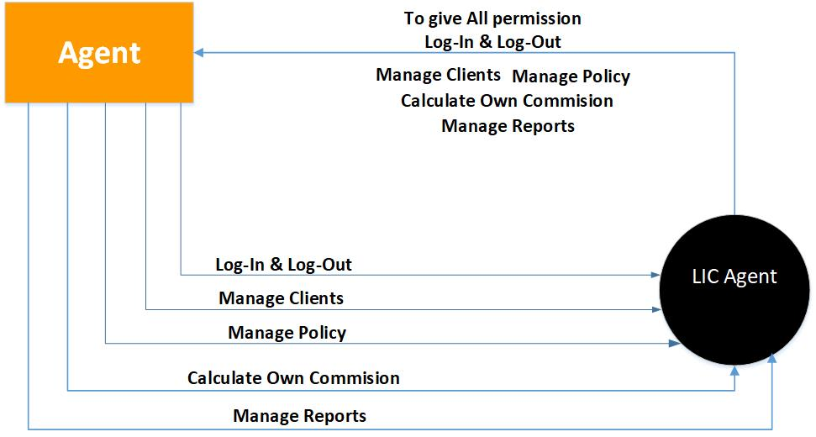

**4.3.2 1st Level Diagram**

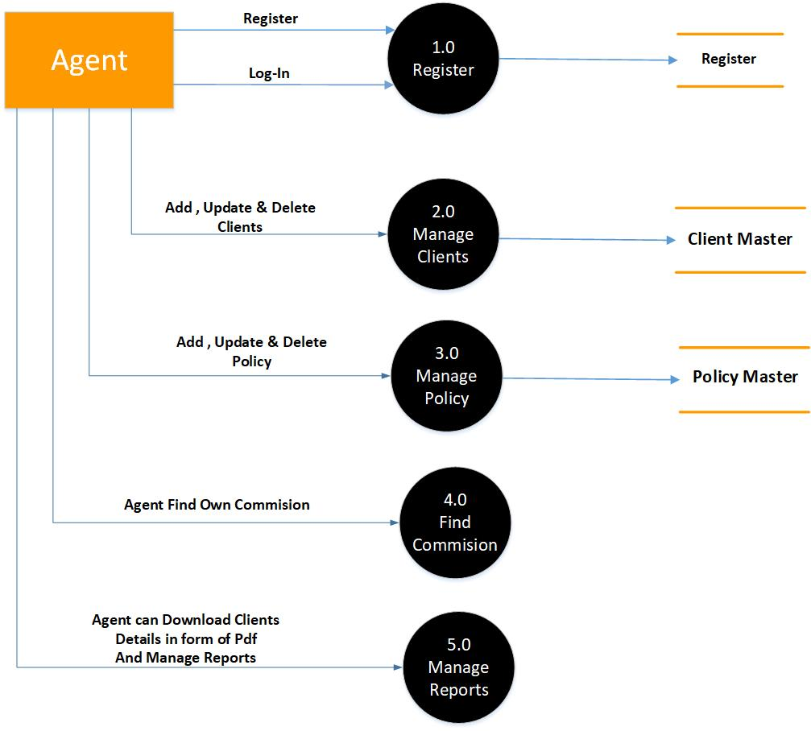

**4.4 E-R Digram :**

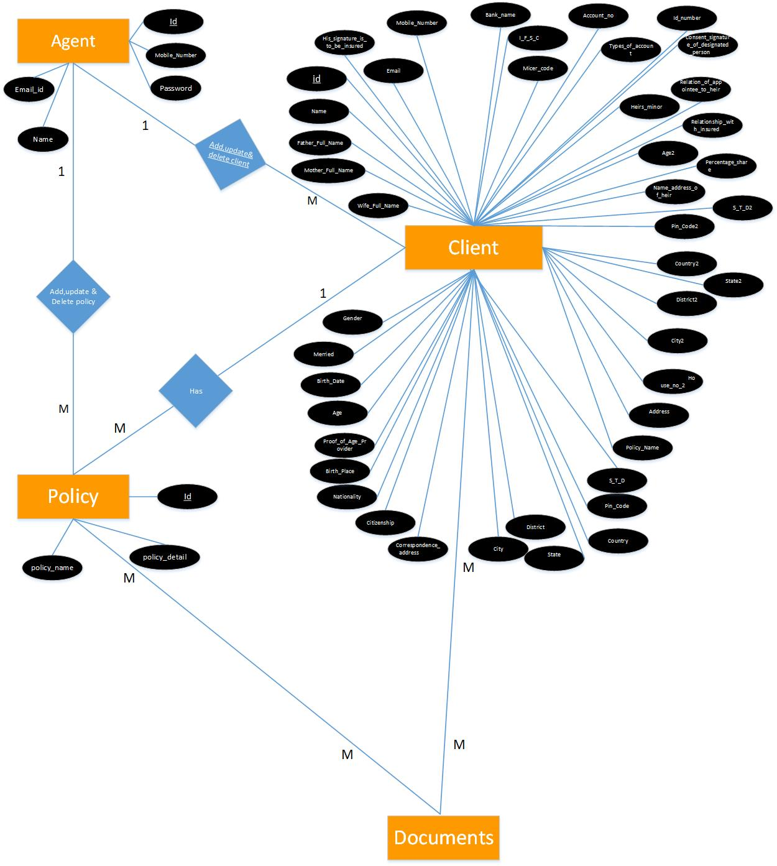

**4.5 Use-case Diagram**

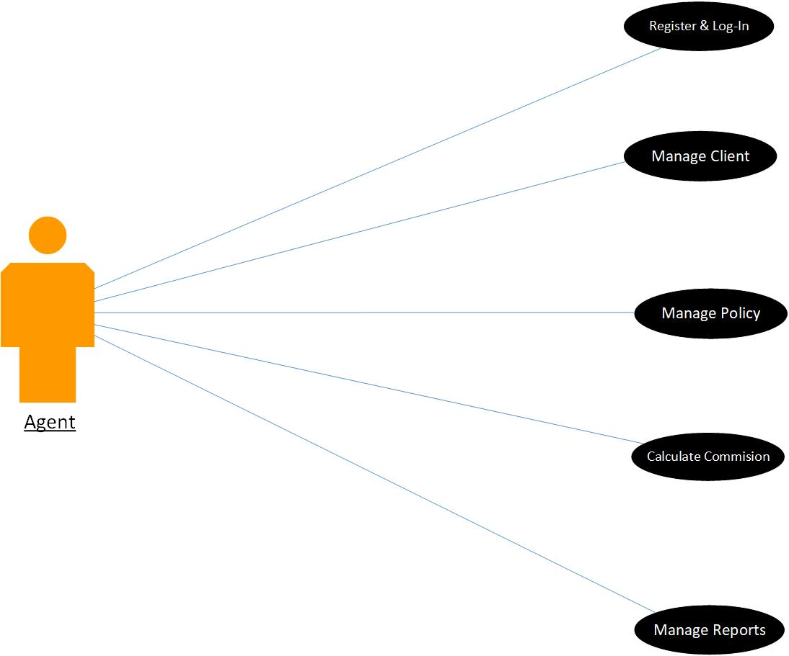

**4.6 Gantt Chart**

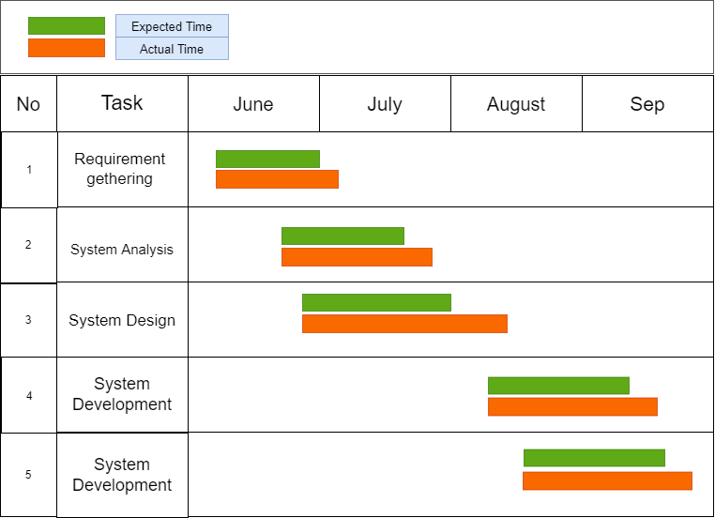

**CHAPTER - 5**

**TSET CASES**

|  |  |  |  |  |  |
| --- | --- | --- | --- | --- | --- |
| Login Module | | | | | |
| TEST CASE No. 1 | | | TEST CASE DESIGN DATE : 19/Sep/2022 | | |
| TEST TITLE : Login Module Test | | | TEST CASE EXECUTION DATE : 19/Sep/2022 | | |
| DESCRIPTION : In this test case Login module would be tested | | | | | |
| PRECONDITION : Login Form must be working | | | | | |
| STEP No. | TEST STEP | TEST DATA | EXPECTED RESULT | ACTUAL RESULT | STATUS |
| 1 | Log-In Form | Login Form | Login Form is visible | Same As Expected | PASS |
| 2 | Enter Email | Darshar.gmail | Email is accepted | Invalid Email | FAIL |
| 3 | Enter Password­­­­­ | darshan | Password is accepted | Same As Expected | FAIL |
| 4 | Click Login Button | Button Click | Check Credentials | Same As Expected | FAIL |

* Note :- Email is not accepted in above test case due to invalid format.

|  |  |  |  |  |  |
| --- | --- | --- | --- | --- | --- |
| Signup Module | | | | | |
| TEST CASE No. 2 | | | TEST CASE DESIGN DATE :  20/Sep/2022 | | |
| TEST TITLE : Signup Module Test | | | TEST CASE EXECUTION DATE : 20/Sep/2022 | | |
| DESCRIPTION : In this test case Signup Activity would be tested | | | | | |
| PRECONDITION : Register Formmust be working | | | | | |
| STEP No. | TEST STEP | TEST DATA | EXPECTED RESULT | ACTUAL RESULT | STATUS |
| 1 | Register page | Register  page | All fields are visible | Same As Expected | PASS |
| 2 | Enter All Fields | Data | Check Data Integrity | Same As Expected | PASS |
| 3 | Click Register Button | Button Click | Register is done  With all Validation | Same As Expected | PASS |

**CHAPTER - 6**

**SCREENSHOT**

* **Admin side**

1. **Register Page**



* In This the User can log in with name, Mobile Number, and Email.
* User password and confirm password must be the same otherwise user can not register.

1. **Login Page**

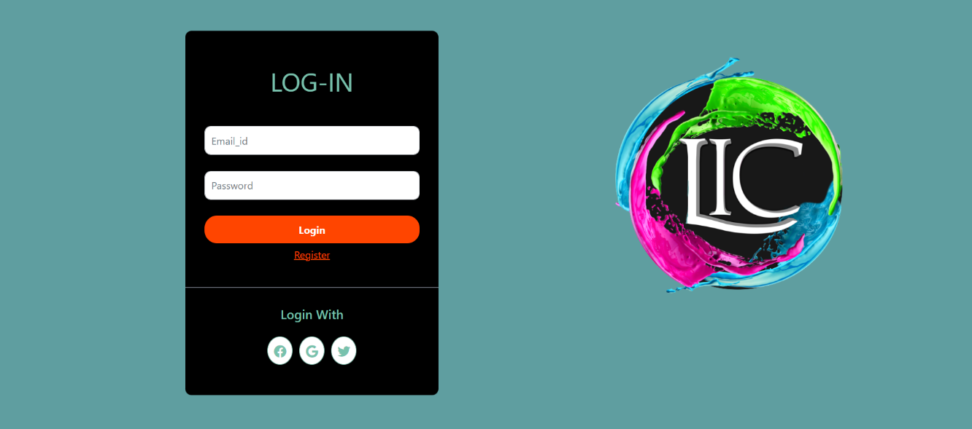

* After registration is completed the user can log in with their credentials.
* If the user inputs the wrong credentials an error will be generated.

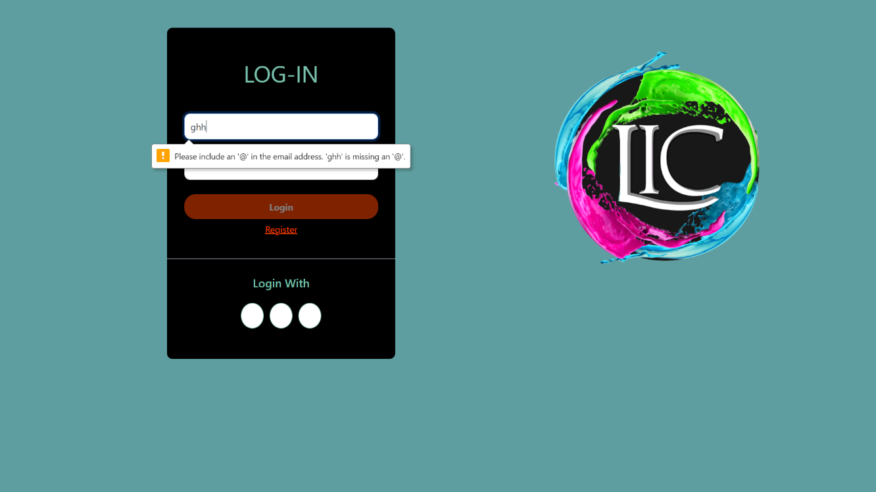

* Invalid Email format

1. **Dashboard**



* This photo is User Dashboard

1. **Insurance page**

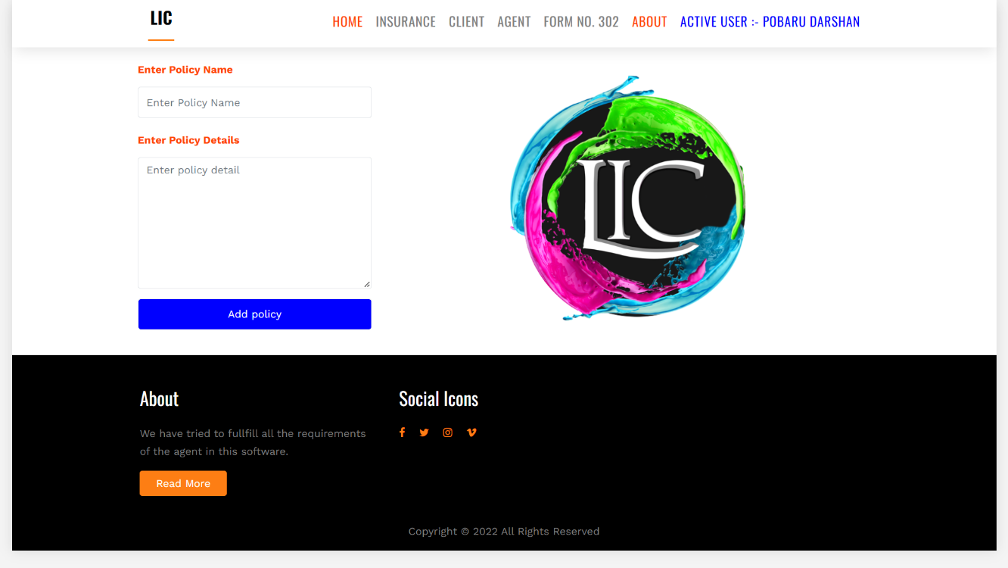

* Add new Policy.
* Display Policy Records.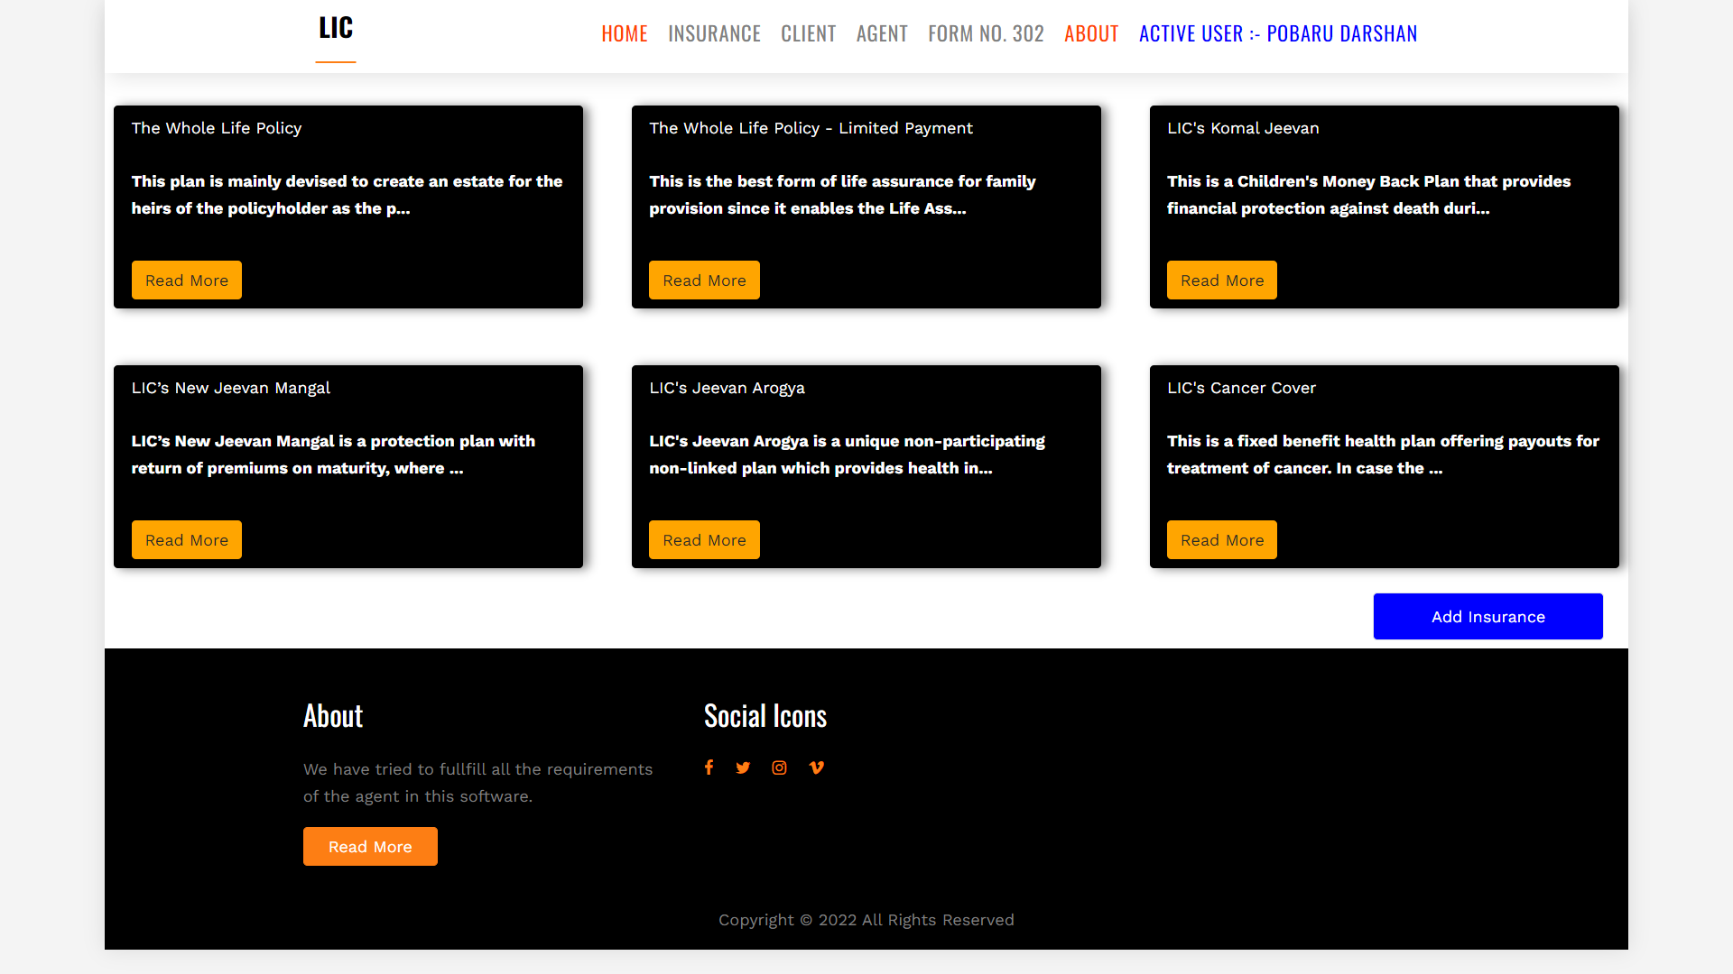

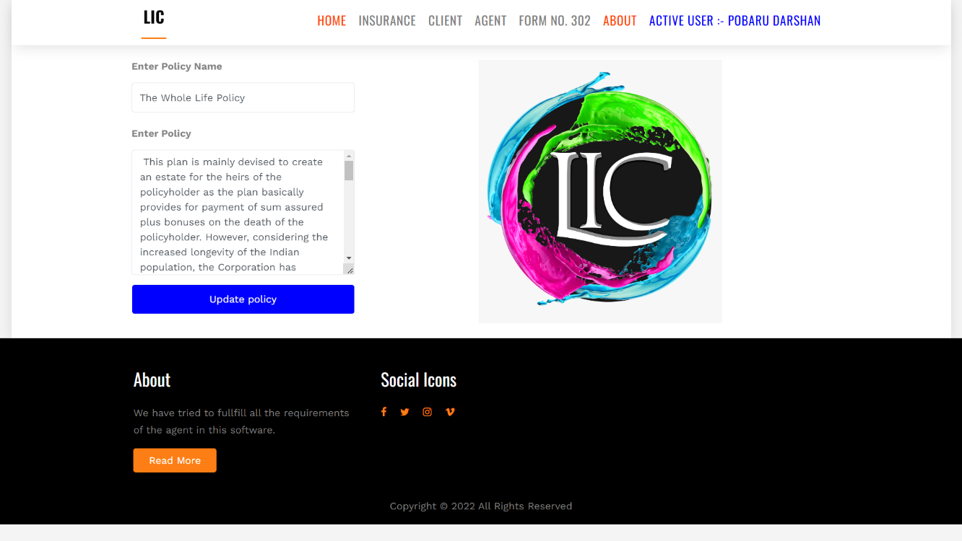

* Update Policy Record.

1. 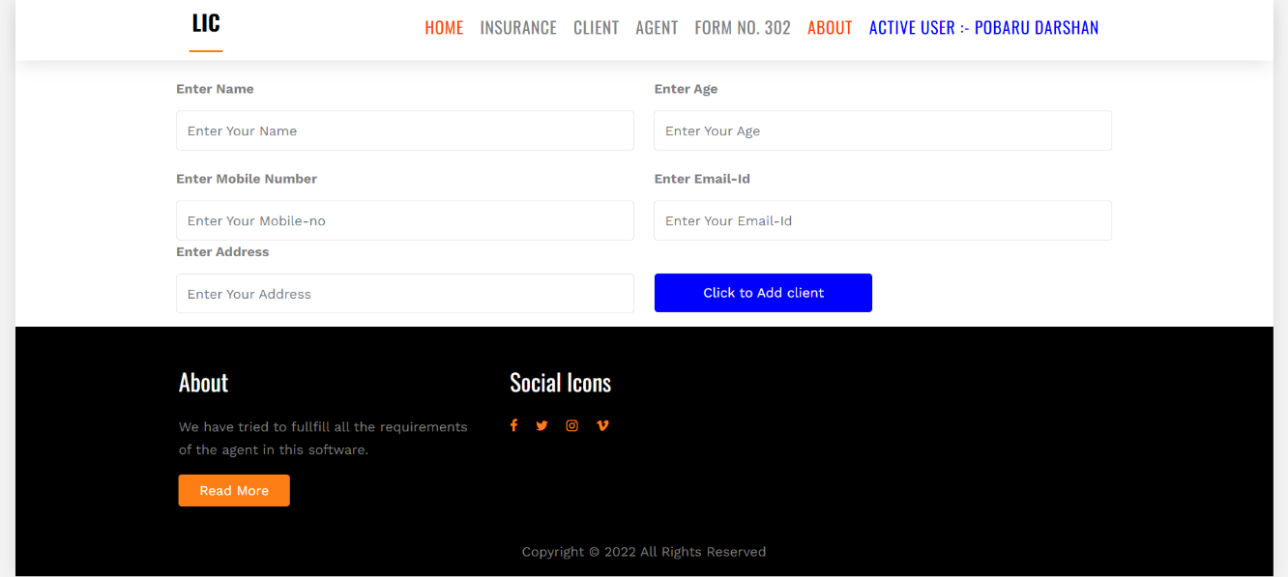**Client**

* Agent can add new clients details.

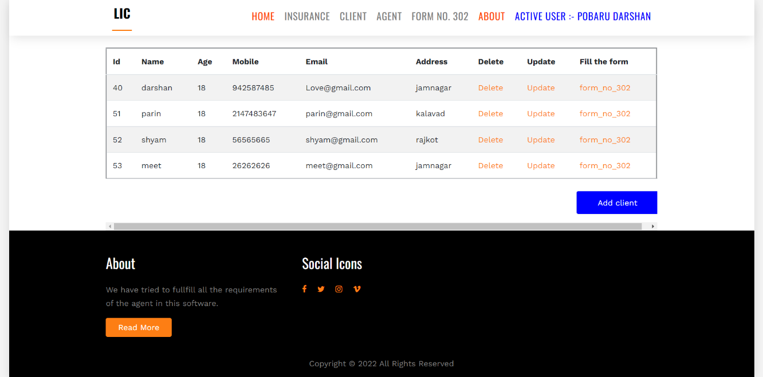

* Display all clients records.

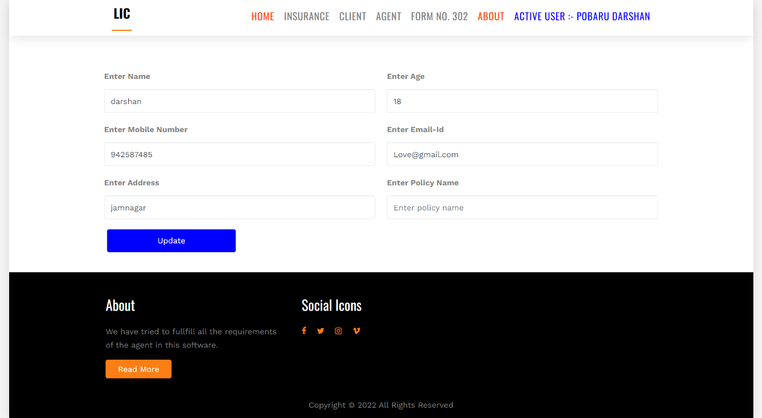

* Update client details.

1. **Form_no_302 details table**

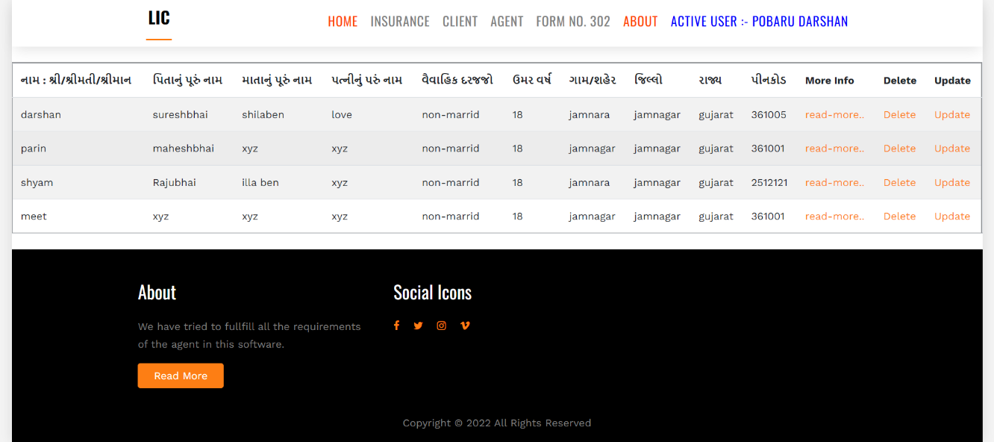

* Here agent can fill form_no_302. Form_no_202 is mainly used for taking policy for people above 18 years age.

1. **Form_no_302**

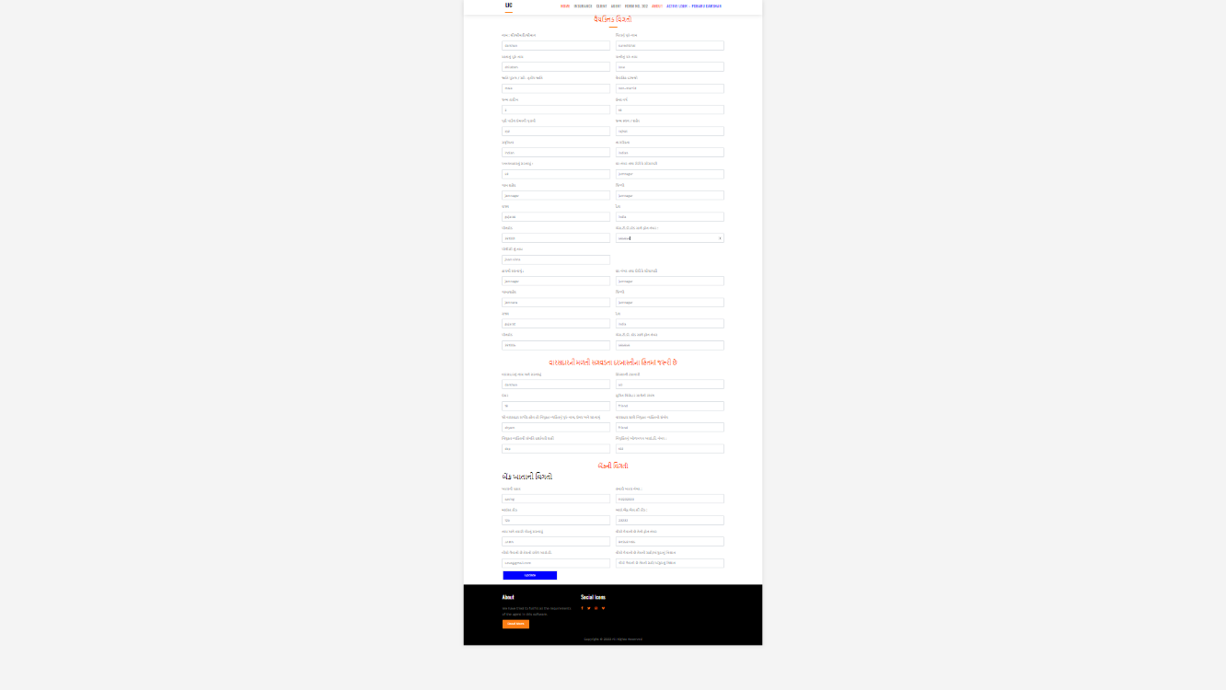

* Fill the form_no_302.

1. **Agent Commission**

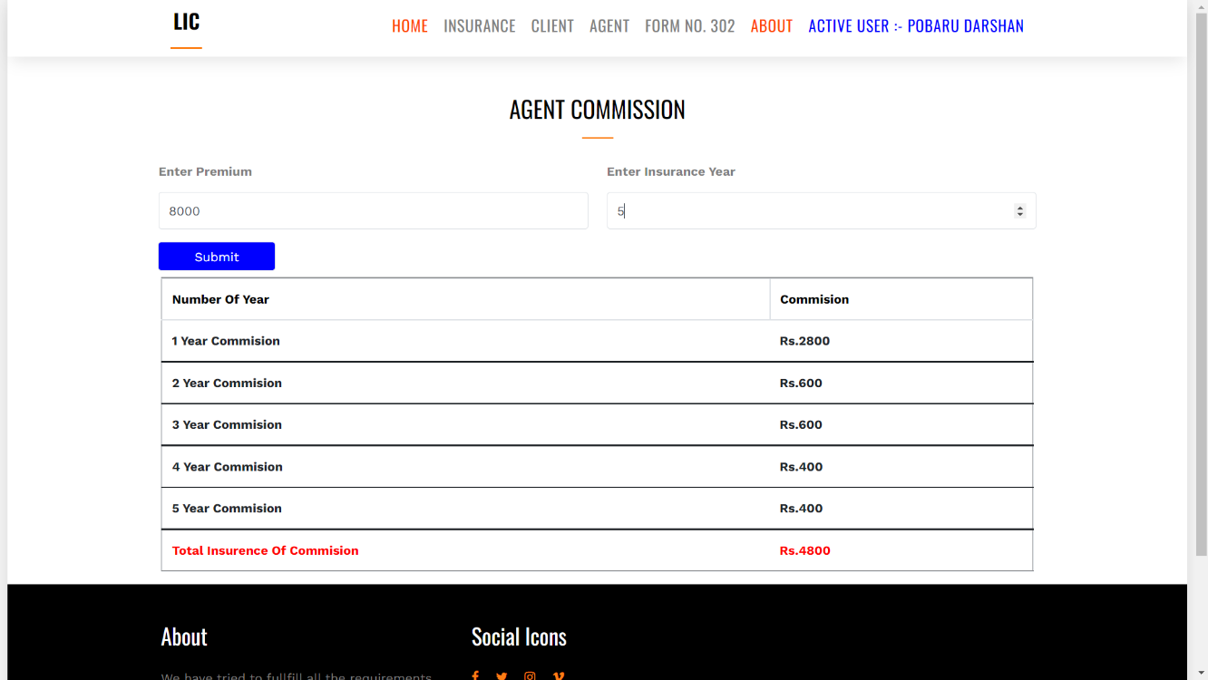

* Agent can find own commission per client.

1. **View client records**

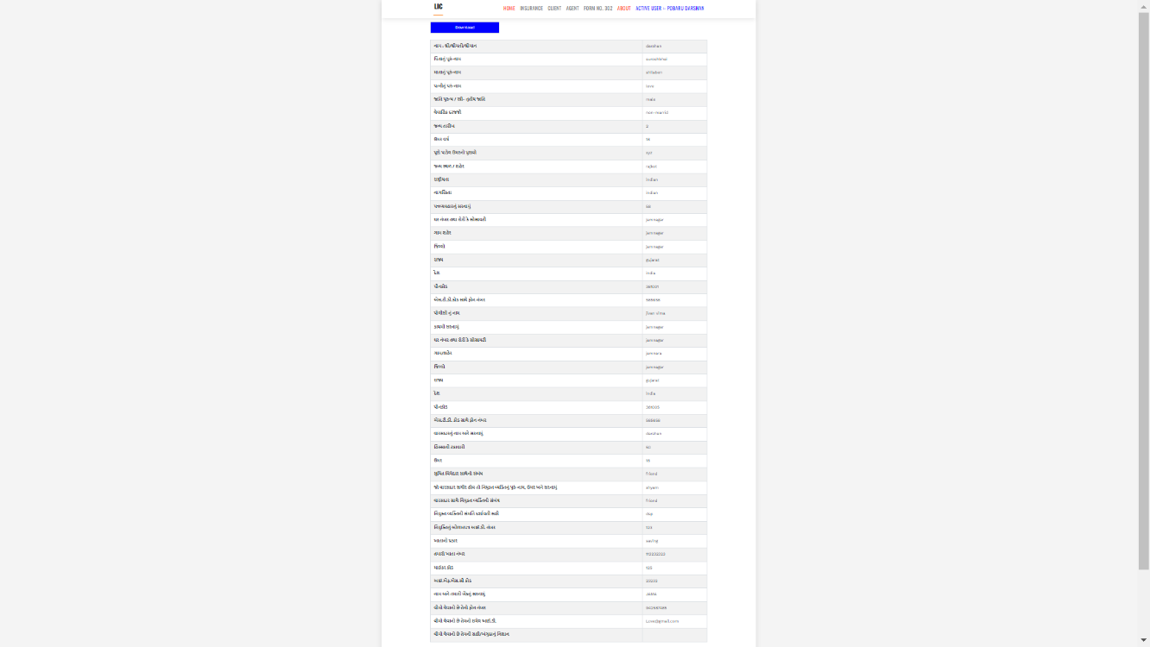

* Agent can view full records his clients.

1. **Download PDF**

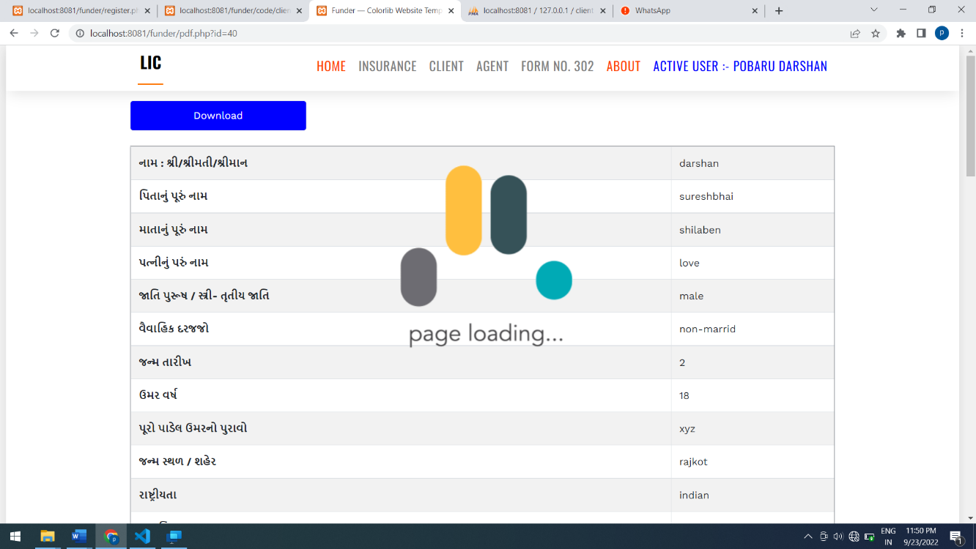

* Agent can download pdf for client details.

1. **PDF view**

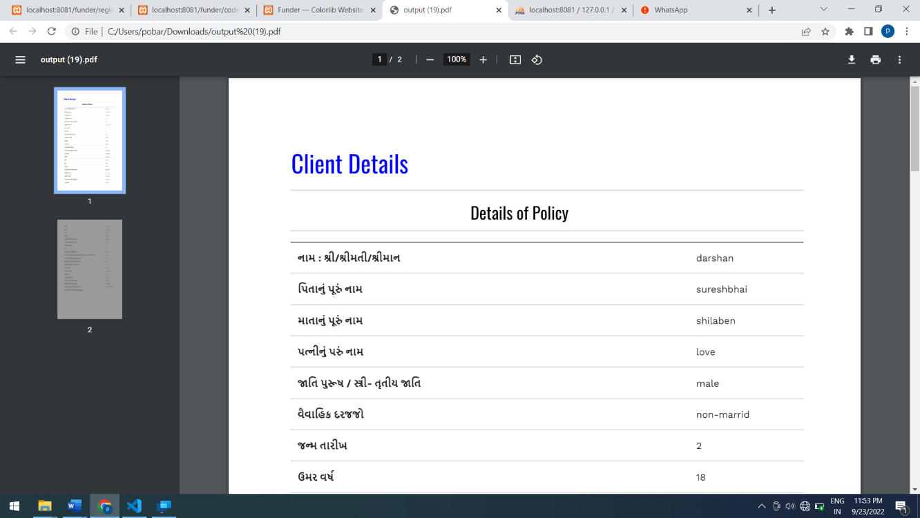

* This is pdf view of client details

1. **Log-out Page**

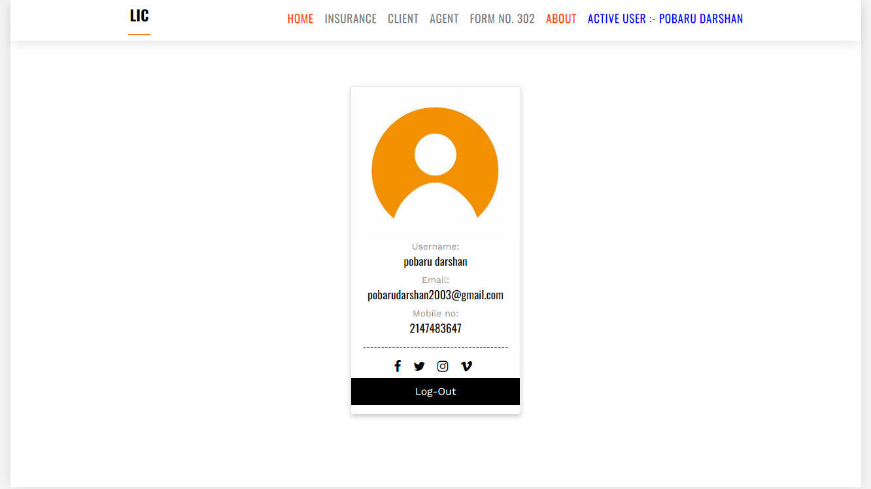

* **Log-out Page.**

**CHAPTER - 7**

**Limitations and Future Enhancements**

**7.1 LIMITATIONS: -**

* The figure of commission received is no exact.
* It takes some time to download the pdf.
* Records once deleted do not come back.

**7.2 FUTURE ENHANCEMENTS: -**

* Records can be stored very easily.
* Easily find own commission.
* Data view in pdf format.

**CHAPTER - 8**

**Conclusion**

* This software is a mostly useful agent agent. Agent can store client information and store policy records. With fully security. agent can insert , update and remove client data. And add new policy and change policy records also can remove policy records.
* Agent can find own commission(Only enter two values).
* Agent can download pdf for it’s client records and store permanent.

**CHAPTER - 9**

**References and Bibliography**

* [***https://stackoverflow.com/***](https://stackoverflow.com/)
* [***https://www.w3schools.com/***](https://www.w3schools.com/)
* [***https://getbootstrap.com/***](https://getbootstrap.com/)
* [***https://www.tutorialrepublic.com/***](https://www.tutorialrepublic.com/)

**BOOK**

* ***Bharat and company PHP Book***
* ***C.Jamnadas & Co. HTML Book***